Music Rudiments Name___________________________
Worksheet 5.1

- Download the music notation software MuseScore from https://musescore.org/.
- Enter the following melody and text.

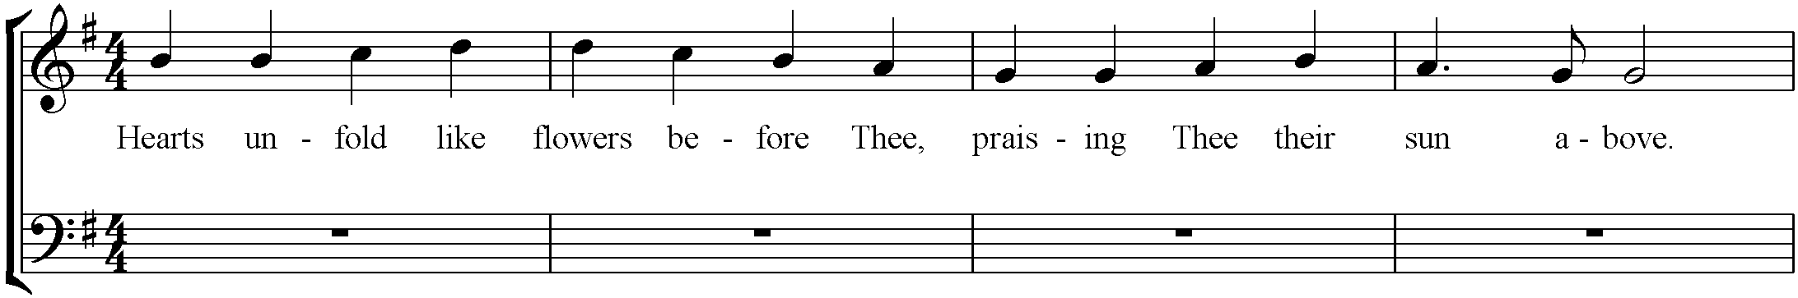

- Harmonize each note of the melody using I, IV, and V chords. First and last chords should be I chords. Be sure the melody note is part of the chord you choose or it will not harmonize.
- Place the chords on the bottom staff in root position (chords should look like snowmen). There should be one chord per melody note.
- Check your work by listening to the composition. Do the chords sound like they harmonize? Type the Roman Numeral of the triad under each snowman.

Inputting notes and chords
- To input single notes type the letter of the note on the keyboard.
- Use CTRL + up or down arrow keys to move notes up or down an octave.
- During note entry, the insertion point automatically advances in the score. If you want to add a chord note to your previous entry, hold SHIFT and type the letter of the pitch you want to add.
- Press CTRL+L to enter lyrics or other text.

