Music Rudiments Name___________________________
Worksheet 5.3
Composing alto and tenor lines

- Write alto and tenor lines at the same time.
  - Move to the nearest chord tone when possible.
  - Make sure all notes of the triad (snowman) are represented.
  - Observe the following vocal ranges.
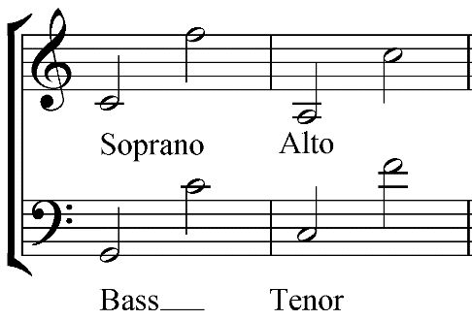
- Avoid the following:
  - Do not change given melody.
  - Voice crossing (tenor higher than alto, or alto higher than soprano, etc.)
  - Lines that jump around a lot and are hard to sing
  - Exceeding vocal ranges
  - Omitting any of the three notes of the triad.

To Submit:
- Email to MrMartin@FaithHighSchool.org.
- Print out and turn in a paper copy.

