Music Rudiments Name________________________

Worksheet 5.4
Polishing Harmonization

Polishing a Composition
- Correct any of the following mistakes in your composition
  - Parallel octaves, fifths, and unisons.
  - 2nd inversion where the 5th of the triad is in the bass.
  - Voice-crossing (vc).
  - Non-chord tones (nct).
  - Exceeding the range any of the voices.
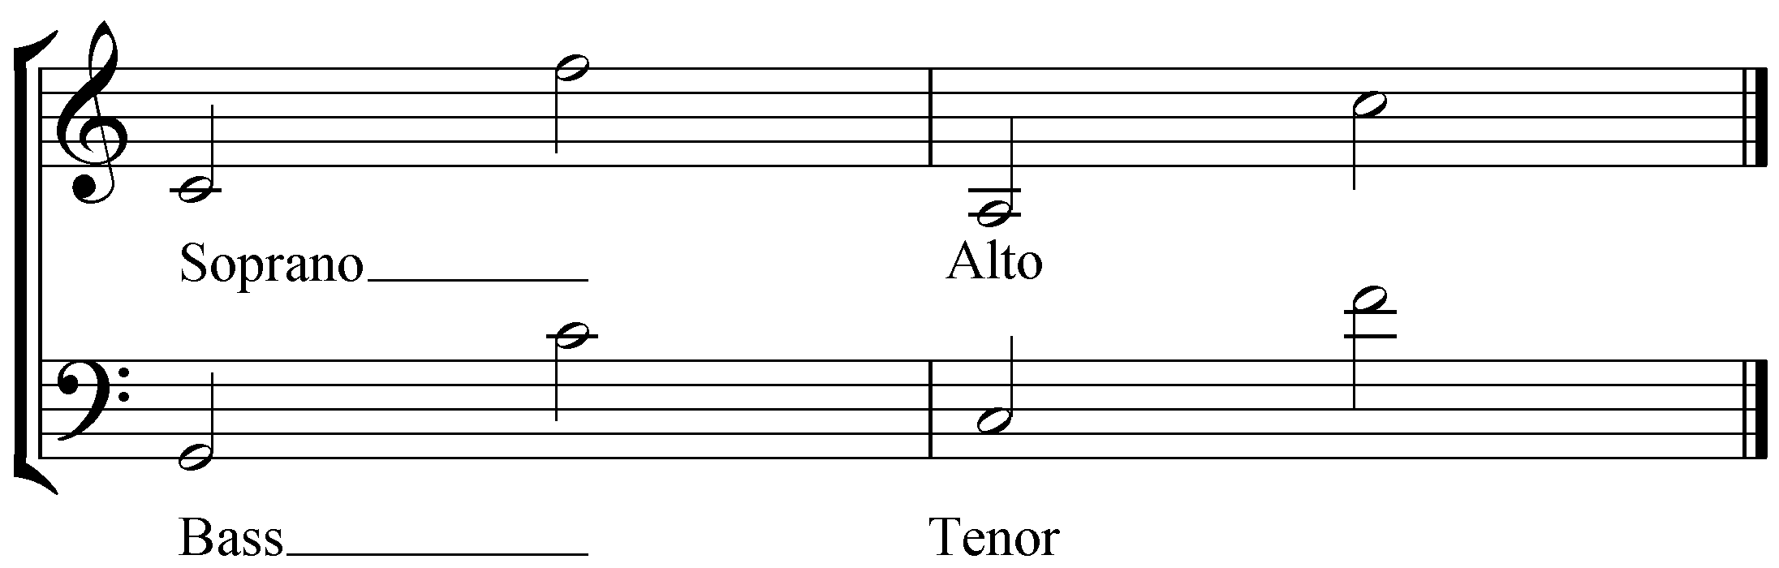

- Rewrite the lines to conform to the rules:
  - Sometimes you can solve a problem simply by swapping notes between two voices. Keep the melody the same, however, and watch that you don't create other problems.
  - Sometimes you may need to back up one or two chords to a point where you have another choice in how the chord is voiced or arranged. Then try rearranging the pitches in a manner that doesn't form new problems (i.e. voice crossing, exceeded ranges, etc.) and try moving ahead with the voices on their new paths.
  - If problems still arise, you may need to change the bass line or chord selection. Do not change the melody.
  - Leaps greater than a third often cause voice leading problems. If you see a large leap (4th or greater) within one or two chords of your problem area, go back and rewrite the part so as to reduce or avoid the leap.

